

**Performance Management Information System (PMIS) User Guide**

2016 Version 1.2

(This is a draft for review and corrections)

**Foreword**

**By: PMED chief**

**Table of Contents**

1. System Overview
2. PMIS Database
3. Data Collection Timeline
4. Level of User Access
5. User Log-in
6. Homepage
7. Data Inputs
8. My Work and Financial Plan (WFP)
9. Budget Execution Documents (BEDs)
10. Quarter – Accomplishment
11. Beneficiary (Actual List)
12. Data Outputs
13. My Reports
    * Work and Financial Plan (Annual)
    * Budget Accountability Report (BAR)
    * By District
14. My Performance
    * Monthly Financial Performance Report
    * Monthly Physical Performance Report
    * Physical Performance Report by Units
    * Physical Performance Report by MFOs
    * Total Individuals Distribution by Sex
    * Beneficiary Accomplishment by Quarter
15. My Account
16. My Profile
17. Change Password
18. Change Avatar
19. PMIS NEW FEATURES
20. Table Pagination
21. Monitoring & Evaluation Account
22. Downloads – Export Data to Excel
23. **System Overview**

The purpose of the Performance Management Information System (PMIS) is to house data regarding the work and financial plan (the baseline) of every banners/programs based from the Major Final Outputs (MFOs) of the department and the accomplishment of each banners/programs. This data is then processed, integrated, and stored in a centralized database (or data warehouse) where it is constantly updated and made available to all who have the authority to access it, in a form that suits the organization’s purpose.

1. **PMIS Database**

A new PMIS database is created each year and the data is then stored in the data warehouse as a central repositories for future references. This database is updated throughout the year during scheduled data collection periods. The MFOs indicators are immutable and only the database administrator can updates, remove or add a new indicator in the system, the same also with the address namely the province, municipal and barangay.

1. **Data Collection Timeline (to be complete c/o M&E)**

The WFP and the accomplishment report data must be submitted during scheduled data collection periods. The following is a description of the general data collection periods for the PMIS.

1. **Level of User Access**

There are two levels of user access to the PMIS:

* Banners/Programs Update – Users can View, Extract and Modify the data.
* Monitoring & Evaluation View – Users can View all the banners/programs data, Extract the data but cannot modify the data.

1. **User Log-in**

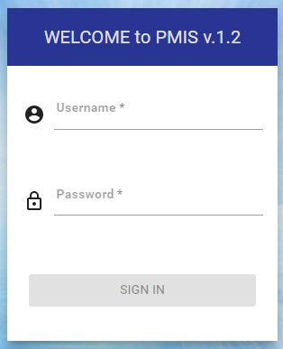

1. Log-on to the PMIS at
2. Enter the appropriate information into the Username field
3. Enter the desired information into the Password field
4. The Sign-in button will become enable to click

*Note: Only the Database Administrator can add an account to the PMIS. After you get the account you can able to customize it or change your profile.*

1. **Homepage**

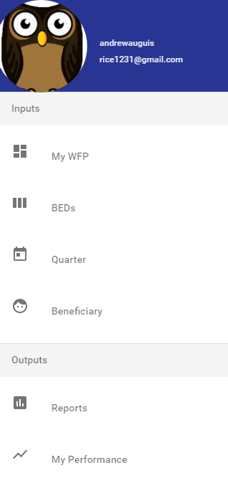

**Show Menu Icon** – when click the menu will open on the left side. The menu item was categorized by inputs and outputs sub-header

**More Settings Menu Icon** – when click the bottom sheet will appear. It contains my account menu item, downloads item and log-out menu item.

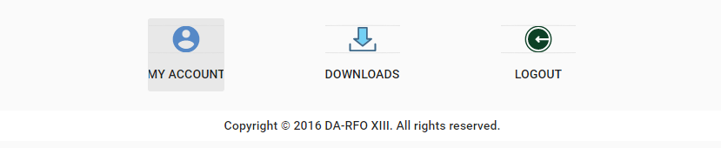

1. **Data Inputs**

Data Inputs section composed of My WFP, BEDs, Quarter and Beneficiary.

1. **My Work and Financial Plan**

My Work and Financial Plan (WFP) menu is the default page of the PMIS after you log-in in the system. This is the first step where you input your work and financial plan (baseline). It includes physical, financial and beneficiary inputs where you can navigate it through clicking the tabs. The physical and financial tab displays a table data of Major Final Outputs (filtered according to banners/programs applicability) and the months from January to December and total per MFOs performance indicator. The MFOs performance indicators are clickable except for the headers, when click the usable form will pop-up to collect your raw data.

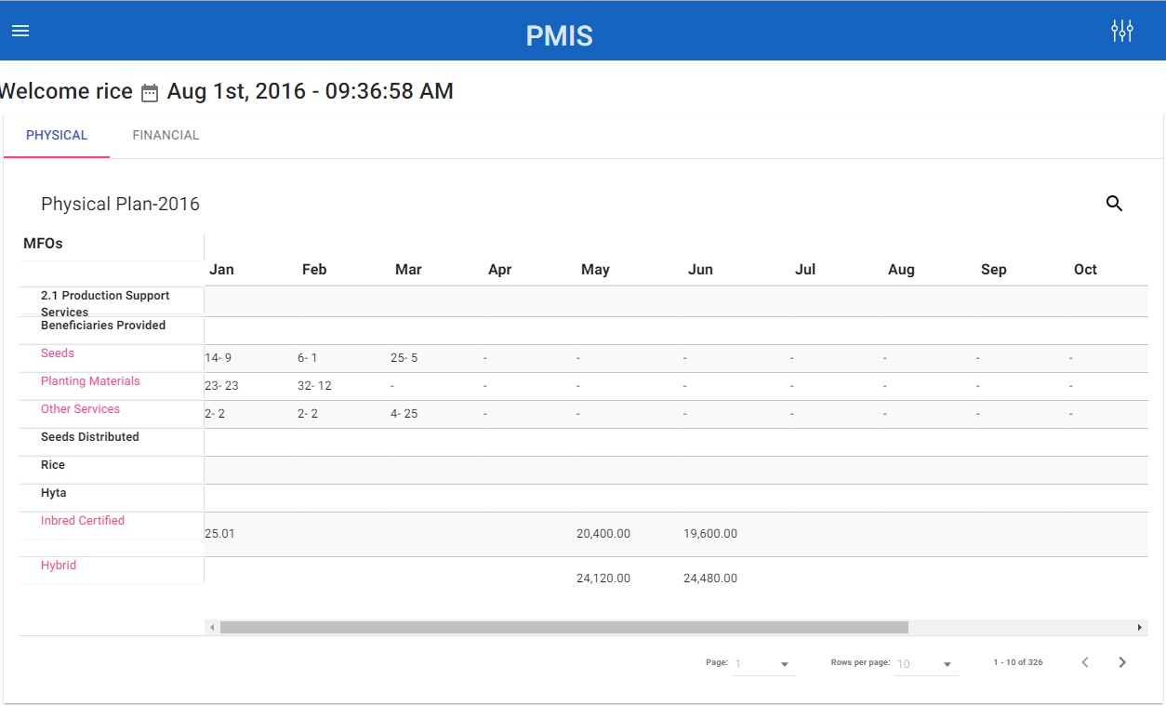

**Usable Forms**

* **Beneficiary Form**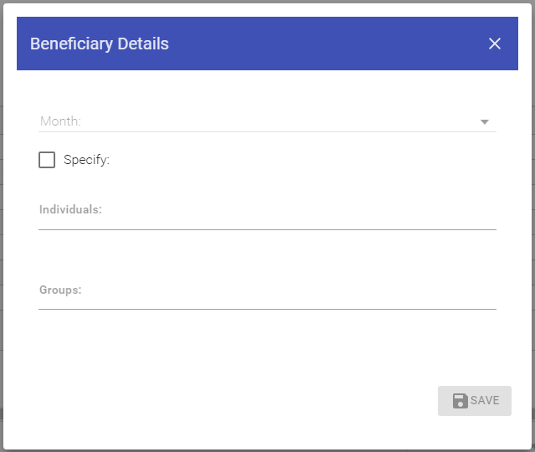

***To add a beneficiary***

1. Select the month – this is required to enable the save button
2. Check the specify button to enter the number of specific male and female beneficiary
3. Otherwise uncheck the specify to enter the total number of individuals beneficiary
4. Enter the total number of groups
5. Click save button when done

After you click the save button the value will display in the cell corresponding to the month and the MFOs indicator.

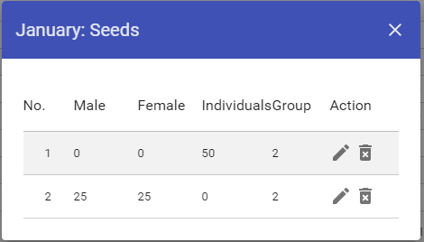

***To edit/delete a beneficiary***

1. To change the value, just click the edit action button then the fields will become editable. When done, click the save button
2. To delete the value, just click the delete action button then the warning modal will pop-up to confirm if you want to permanently delete the value by clicking YES or NO.

* **Physical & Financial Form**

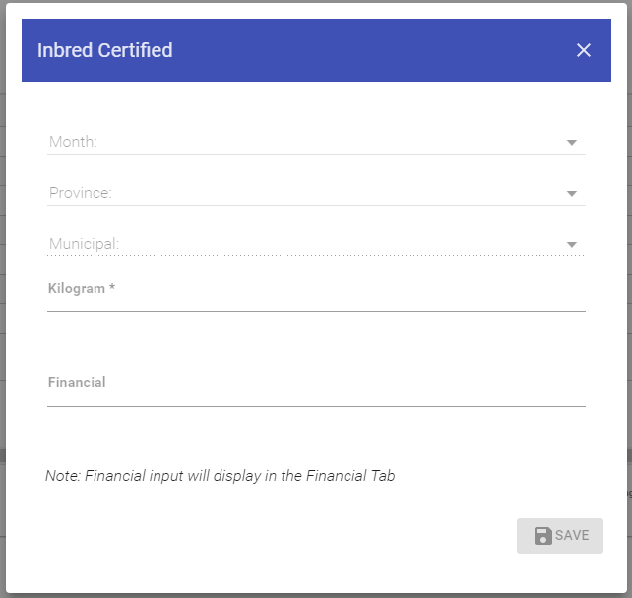

***To add a physical and financial value***

1. Click the MFOs indicator you want to add a physical and financial value, then the adding form will pop-up
2. Select a month - this is required to enable the save button
3. Select a province - this is required to enable the save button
4. Select a municipal - this is optional and will disable if you select RFO
5. Enter the physical value, the units will depend on the MFOs indicator
6. Enter the financial value
7. Click save button when done

After you click the save button the physical value will display in the cell corresponding to the month and the MFOs indicator. The financial value is displayed in another table in financial tab.

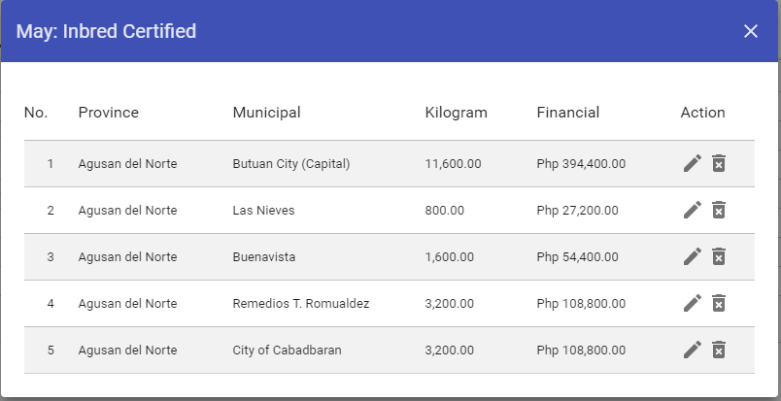

***To edit/delete a physical and financial value***

1. To change the value, just click the edit action button then the fields will become editable. When done, click the save button
2. To delete the value, just click the delete action button then the warning modal will pop-up to confirm if you want to permanently delete the value by clicking YES or NO.
3. **Budget Execution Documents**

Budget Execution Documents composed of BED-1 which is the overall financial (estimated obligations/expenditures) plan and BED-2 which is the overall physical (targeted outputs) plan of the particular banner/program consistent with their approved budget, broken down by quarter. The BED1 and BED2 will display the filtered MFOs indicator that has a value only in the work and financial plan inputs.

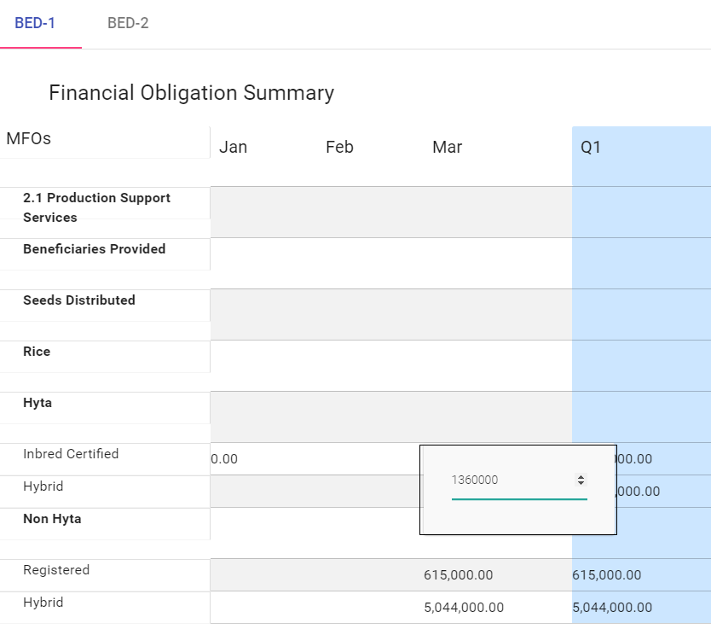

***To add/edit/delete a financial obligation***

In BED-1, the financial obligation should be inputted in the table corresponding to the months and MFOs indicator by clicking the cell an edit dialog will display and it's now ready to be inputted. When done, hit the enter button to save the data. If you wish to change/delete the data, just click the value and change the number or delete it by hitting the backspace and hit enter.

In BED-2, the table displays the physical value summary of each MFOs indicator by months and quarter. This table is not editable; if you wish to change the value you can change it in the My WFP section.

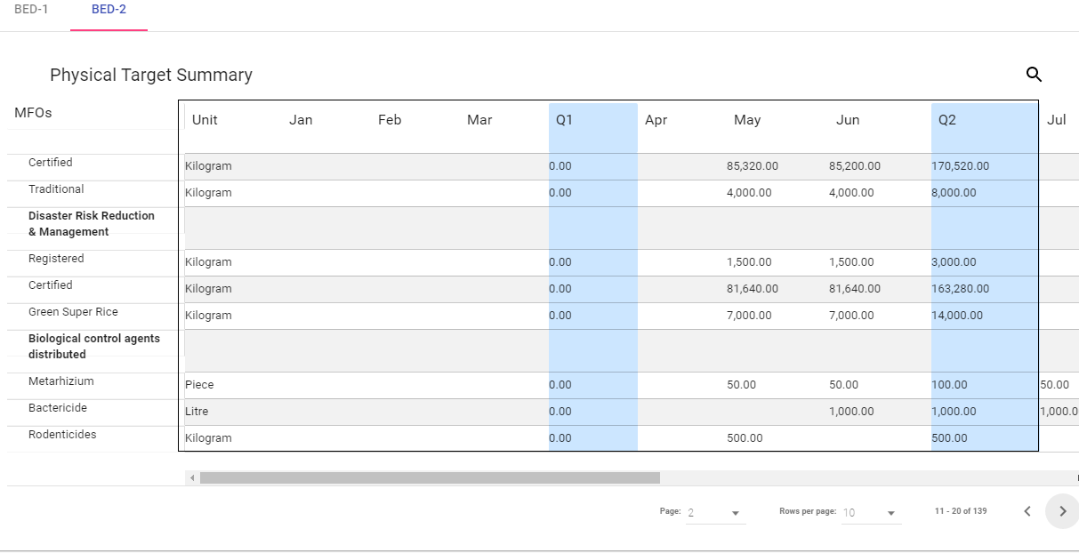

1. **Quarter – Accomplishment**

The accomplishment data of physical and financial will be inputted in the quarter menu. This section displays a filtered MFOs indicator in the table by quarter namely 1st Quarter, 2nd Quarter, 3rd Quarter and 4th Quarter. It includes adding remarks in each indicator except for the header.

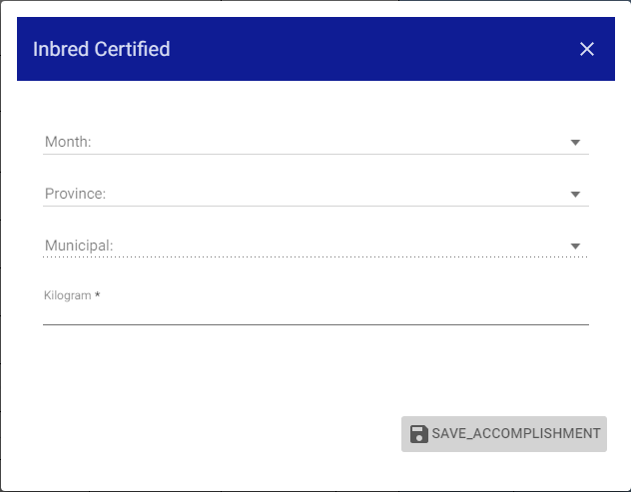

***To add a physical accomplishment data***

1. Click the MFOs indicator. Only the italicized indicator is clickable.
2. The physical accomplishment form will display ready to input.
3. All fields are required to enable the save button.
4. After you click the save button, then the value will display in the physical column based to the month you select.

***To edit/delete a physical accomplishment data***

1. Click the cell in the physical column you want to edit or delete.
2. Then the table will display the details.
3. In the action column, you choose if you wish to edit or delete.
4. If you choose delete, then the dialog will open with an action of yes or no.
5. If you click yes, then the data will permanently remove. Otherwise, the dialog will close.
6. If you wish to edit, then click the edit icon in the action column.
7. The cell will become editable and ready to edit.
8. Click the save button to save changes. Otherwise click cancel.

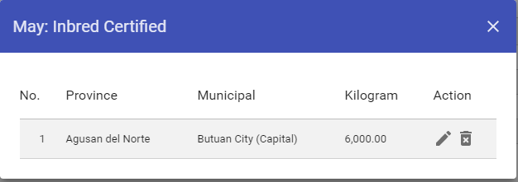

***To add/edit/delete Financial Accomplishment data***

1. Click the cell of the financial column corresponding to the month and the MFOs indicator you want to add.
2. The small dialog will open and ready to input.
3. Press the enter button to save.
4. If you wish to update or delete the value, just click again the cell of the financial column corresponding to the MFOs indicator.
5. The dialog will open ready to change the data or delete the value.
6. Press the hit the enter button to save changes.

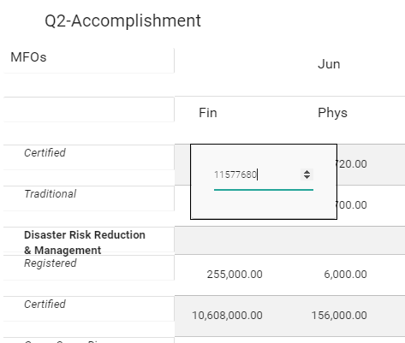

***To add/edit/delete remarks***

1. To add just click the cell in the remarks column corresponding to the MFOs indicator.
2. Then, the dialog will open ready to input (the remark texts can only hold 20 characters).
3. Hit the enter button to save the data.
4. To edit, just click again the cell and change the text and hit enter to save changes.
5. To delete, just click again the cell and hit backspace to erase the text.

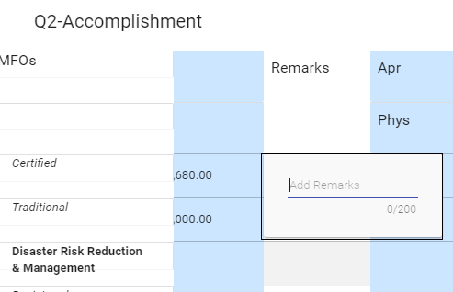

1. **Beneficiary – Actual List**

The beneficiary section displays the list of actual beneficiary of the programs/banners. The section composed of two tabs namely the Groups and Individuals.

* **Groups** – this is the default tab in Beneficiary menu. It will display all the list of groups created by the user, it has the following details:
  + Name of LGU/CSO – this is required
  + No. of Members – auto generate based on the number of individuals. This is clickable.
  + Address – this is required.
    - Province
    - Municipal
    - Barangay
  + Contact No. – this is optional
  + 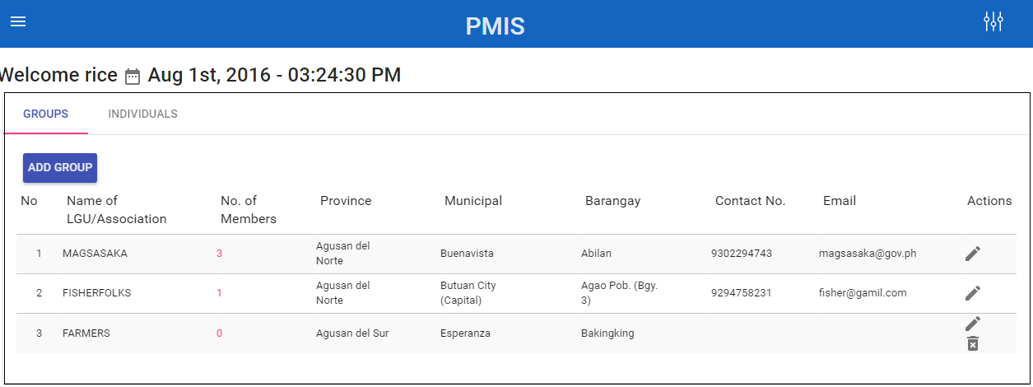Email – this is optional.

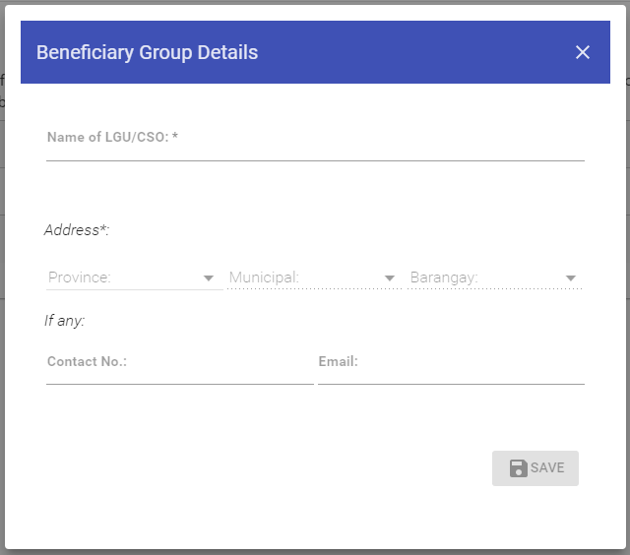

***To add a group***

1. Click the ADD GROUP button
2. The Beneficiary Group will pop-up
3. Enter the Name of LGU/CSO
4. Enter the Address
5. If any, enter Contact No. and Email
6. Click SAVE button

After you click the save button, the group details will be shown in the table.

***To edit/delete a group***

1. To edit, click the pencil icon in the action column.
2. The table data will become editable and ready to input.
3. When done, click the SAVE button to save the changes.
4. To delete, click the delete icon in the action column. The delete icon will show only if the group has no members attached to it.
5. Then the confirmation modal will pop-up, click YES to delete or NO to cancel.

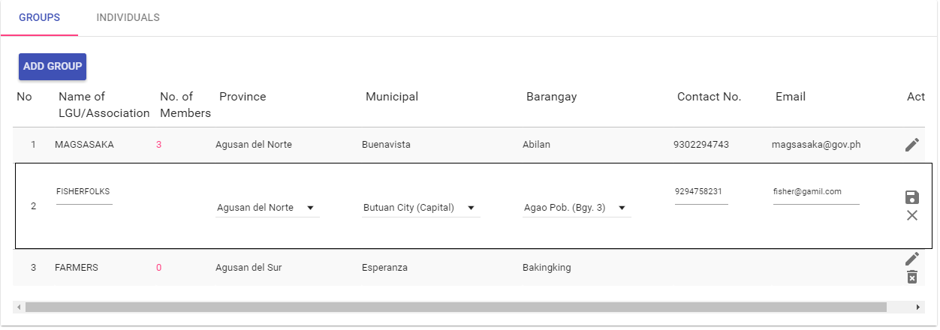

***To vi*ew the members of the group**

The No. of Members column in Group table is a link to view the list of members under of that group. The individual beneficiary table will display the group name in the header with the action column of edit and delete.

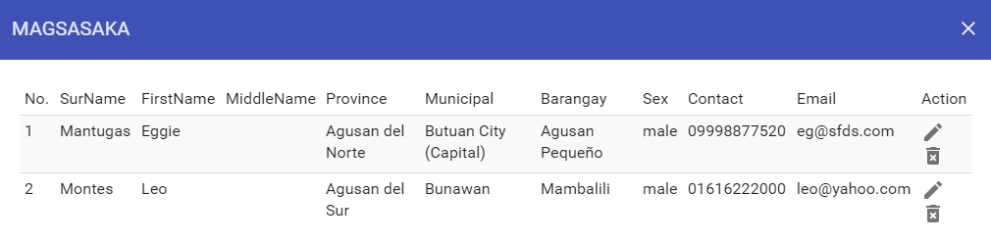

* **Individuals** – this section will display the MFOs indicator under by the beneficiaries provided services. It has the following details.
  + **MFOs** – services received by the beneficiary
  + **Months** – the month availed the services by the beneficiary.

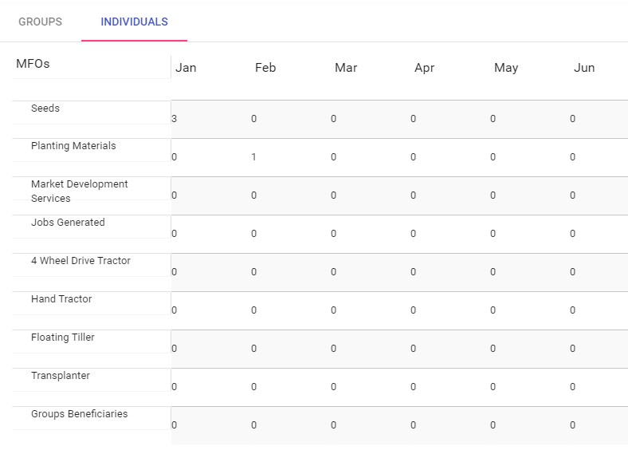

***To add individual in the service***

1. Click the MFO services you want to add.
2. The Beneficiary Individual Details form will pop-up.
3. Select the MONTH, when the client received the services? This is required.
4. Select the GROUP. This will automatically generate the list of all options of group created by the user in the GROUP tab. If the GROUP is not listed then the user can add it in the GROUP tab. This is required.
5. Enter the Surname of the client. This is required.
6. Enter the First name of the client. This is required.
7. Enter the Middle name of the client. This is optional.
8. If any, enter the Contact No. and Email of the client. This is optional.
9. Enter the sex of the client. This is required.
10. The SAVE button will enable if the user will fill-up the required fields.
11. When done, click the SAVE button.

After you click the SAVE button, the number in the cell data corresponding to the MFOs and the month will increment and the number is clickable.

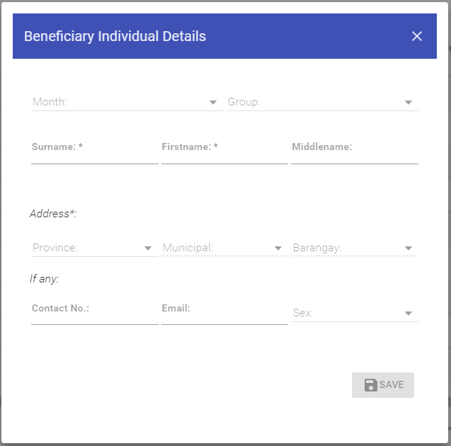

***To view individual in the service***

The numbers inside the table are clickable. If you wish to view the individual beneficiary, just click the numbers and another table will display the details of individual beneficiary. It contains actions column where you can edit or delete the data.

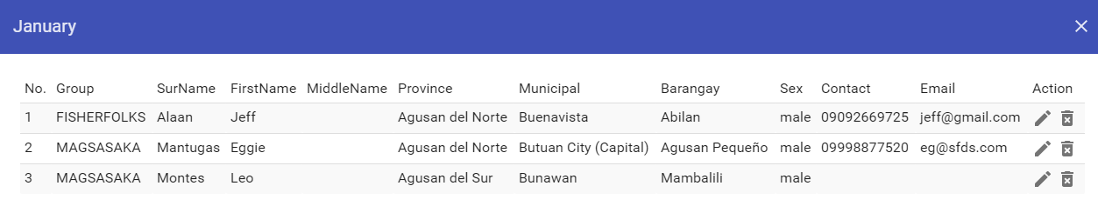

***To edit/delete individual in the service***

1. If you wish to edit the individual beneficiary just click the pencil icon.
2. The fields will become editable, and ready to change.
3. The alert message will pop-up, if and only if you leave empty the required fields.
4. Click the save icon, when done.
5. To delete the individual beneficiary, just click the trash icon.
6. The warning message will pop-up with the action button YES to confirm and No to cancel.

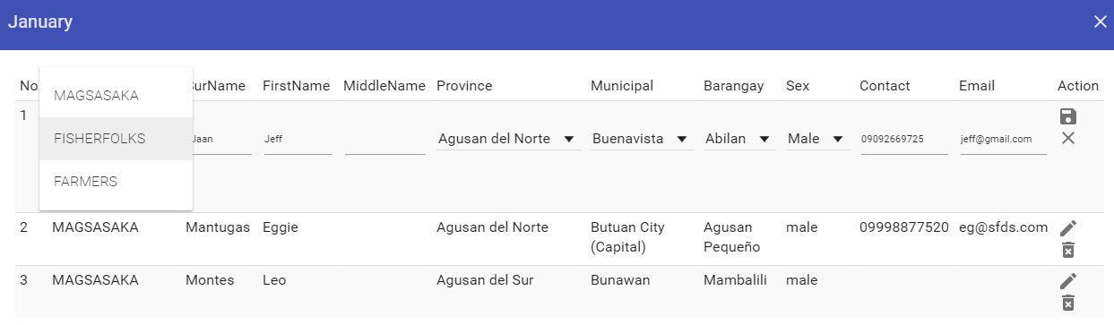

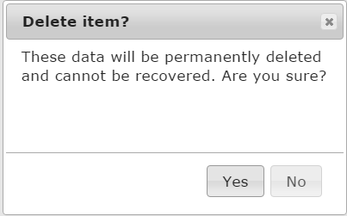

1. **Data Outputs**

Data Outputs section composed of My Reports and My Performance.

1. **My Reports**
2. **Work and Financial Plan** – this page generates an annual summary evaluation of overall physical and financial plan of particular banner/program based on the approved budget for the year. The work and financial plan table consists of Major Final Outputs, Unit of Measure, Physical Target and Financial Allocation. See sample screenshot below.

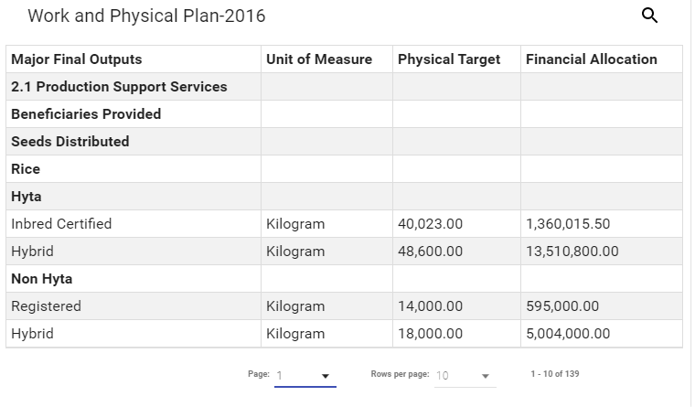

1. **Budget Accountability Report**
   * **BAR 1:** Quarterly Physical Report of Operation – it reflects the banners/programs actual accomplishments in terms of the performance measures indicated in its WFP, break down by quarter. See sample screenshot below.

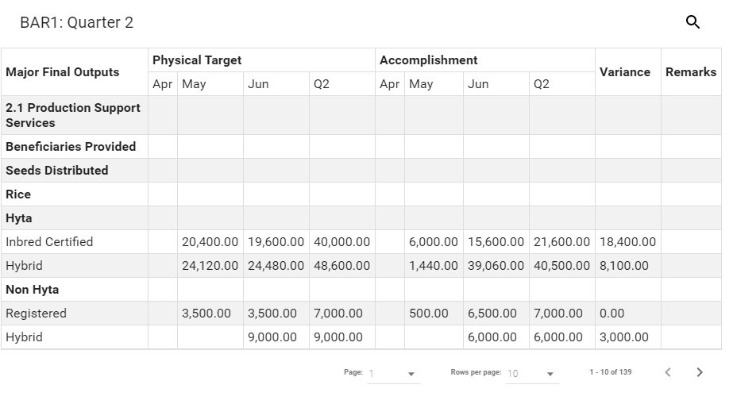

* + **BAR 2:** Quarterly Financial Report of Operation – it reflects the banners/programs actual obligations corresponding to the reported physical accomplishment for the quarter. See sample screenshot below.

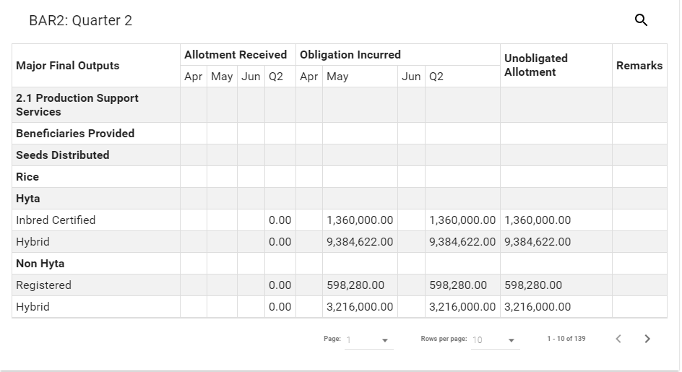

1. **Physical Accomplishment By Province & District** – this page generates an annual physical accomplishment report by district based on the user’s selection of province and district. The Physical Accomplishment table consists of MFOs, Unit, Financial Target, Physical Target, Location, Physical Accomplishment and Remarks where the Location column will reflect the breakdown of physical target areas. Also, remarks are editable where you can add text by clicking the cell. See sample screenshot below.

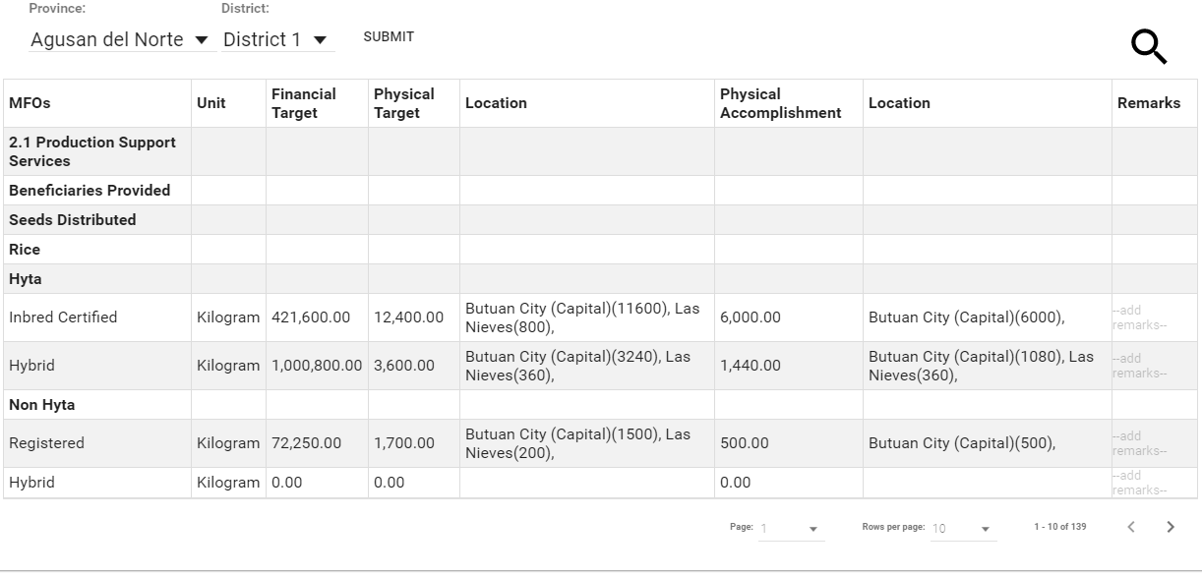

1. **My Performance**

This section displays a comprehensive reporting, analytics and summary performance of particular banners/programs using interactive charts and tables where the user can hover the bar to see the percentage details. The chart and table calculation perform a running total computation by month and the total year value as a denominator to get the percentage per month. To view the data table, the user should click the see data table or the dotted vertical icon found at the bottom of the container where the highlighted data are clickable to see the detailed breakdown content of the said figures.

1. **Monthly Financial Performance Report** – it reflects the banners/programs actual financial performance based on the obligations incurred monthly over the annual allocation target as a denominator. See sample screenshot below.

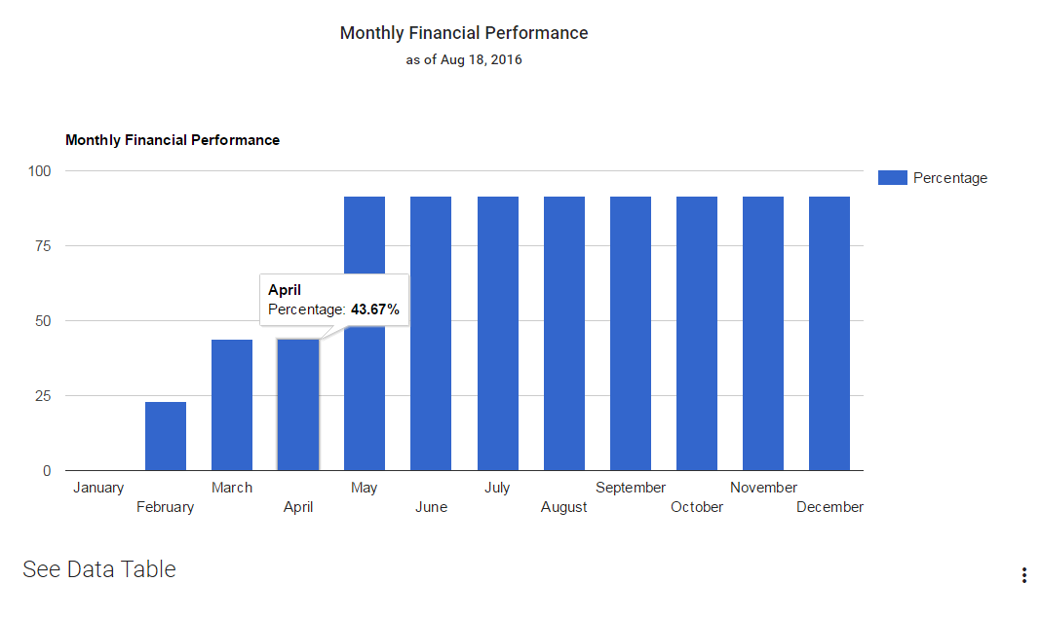

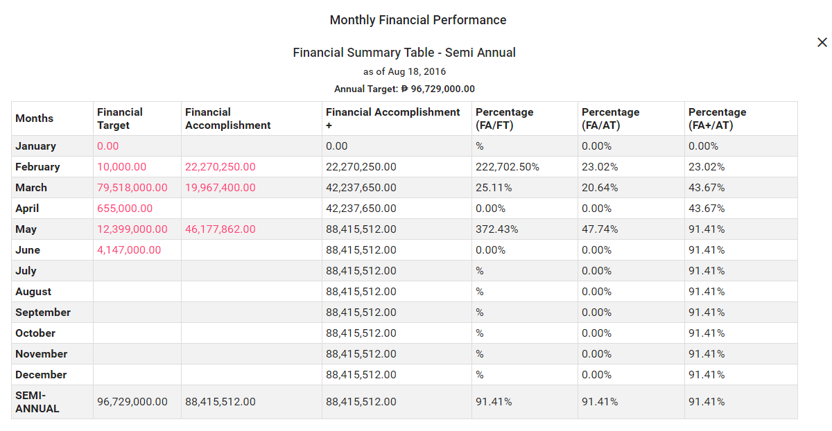

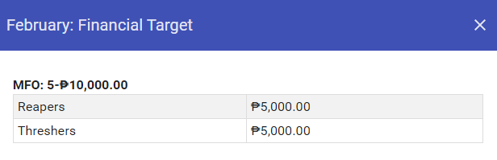

1. **Monthly Physical Performance Report by Units** - it reflects the banners/programs actual physical performance based on the units measure of performance indicator per month. See sample screenshot below.

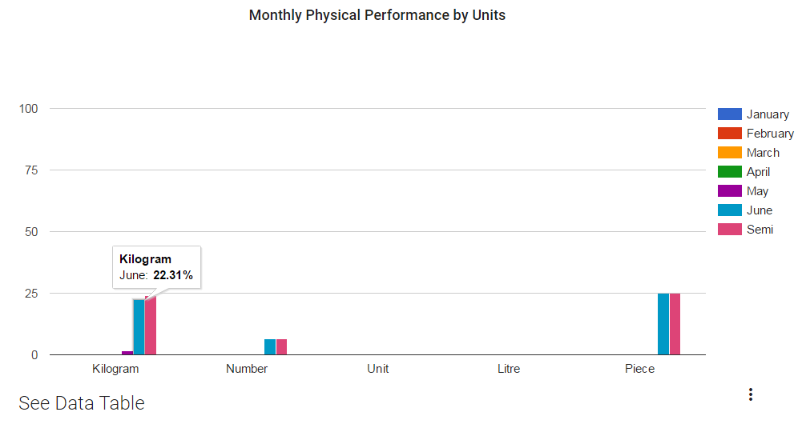

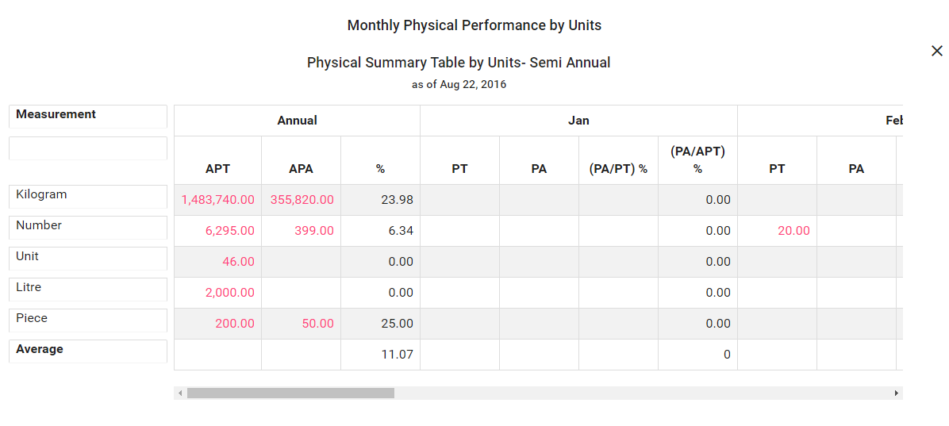

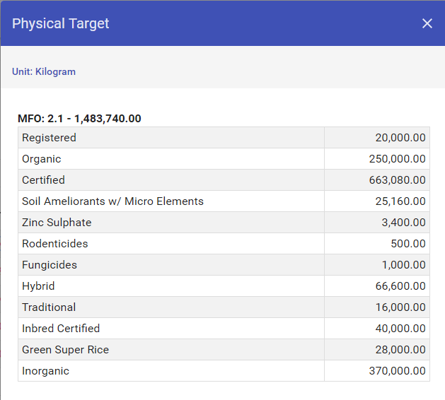

1. **Monthly Physical Performance Report by MFOs** – it reflects the banners/programs actual physical performance based on the Major Final Outputs of the departments per month.

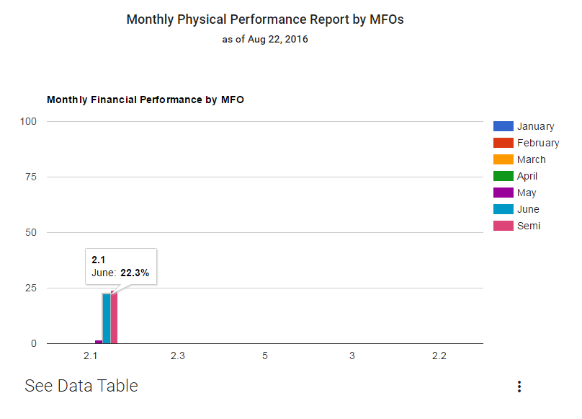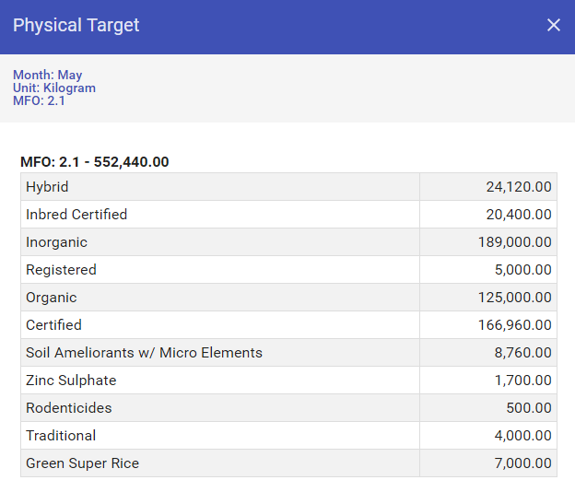

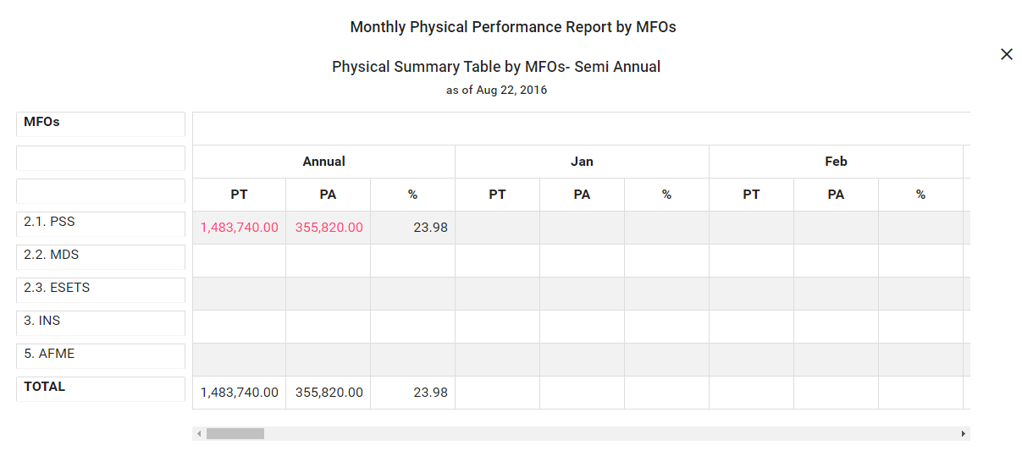

1. **Monthly Physical Performance Report** – it reflects the banners/programs actual physical performance based on the total average of unit measures of the departments per month.

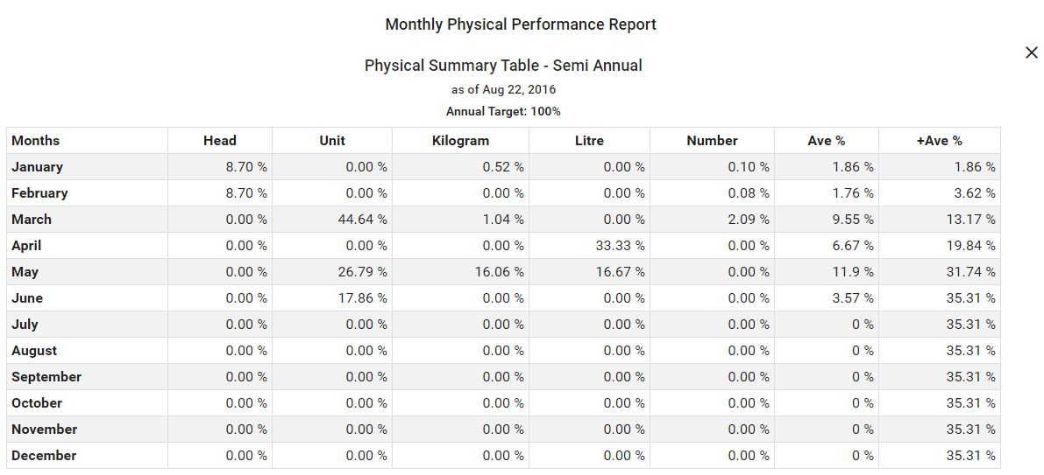

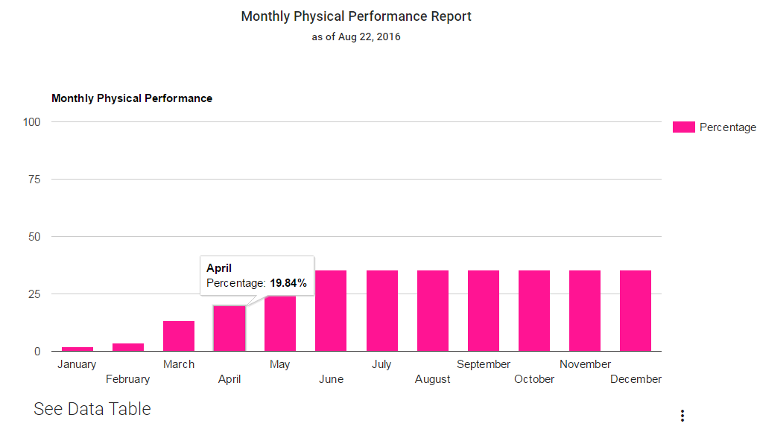

1. **Total Individuals Distribution Report by Sex** – it reflects the total individuals distribution of sex where individuals refers to beneficiary who already received the services.

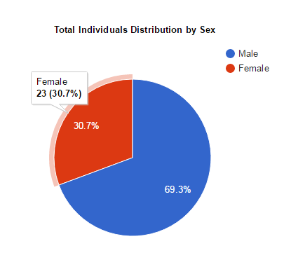

1. 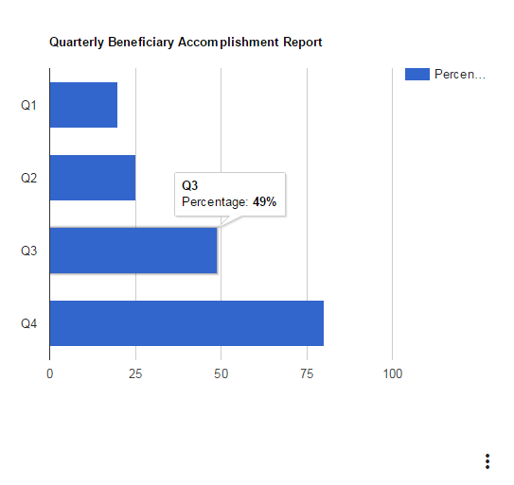**Quarterly Beneficiary Accomplishment Report** – it reflects the banners/programs actual beneficiary accomplishment based on the individuals’ services received monthly over the annual target individuals as a denominator.

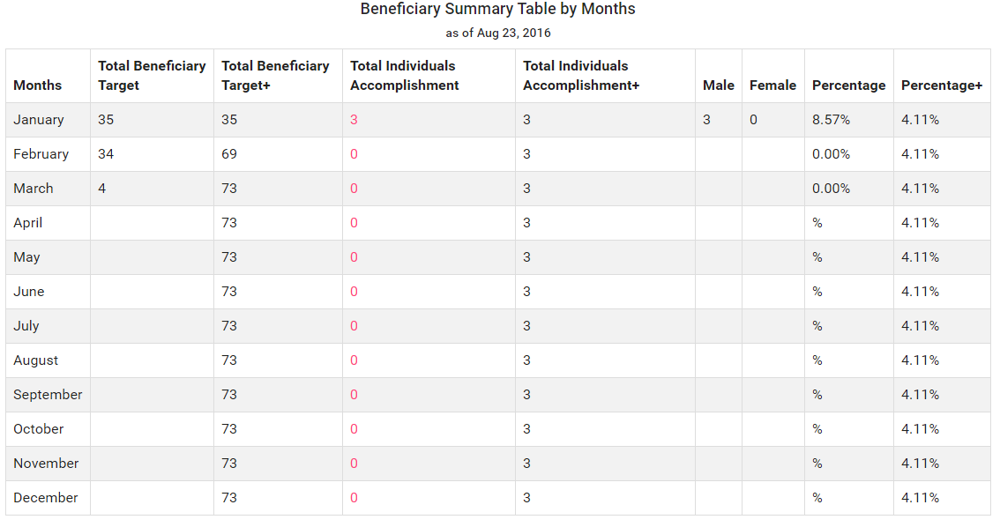

**My Account**

My Account page contains three sections namely My Profile, Change Password and Change Avatar where the user can manage and customize their profile information.

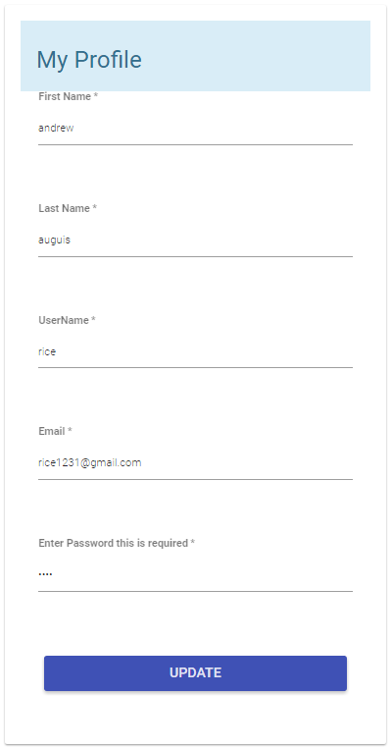

1. My Profile – The table forms will auto display the basic information of the user and the fields are editable. All fields are required to save the changes. It contains the following fields: First Name, Last Name, User Name, Email and Password. To enable the update button, the user must input the correct current password.

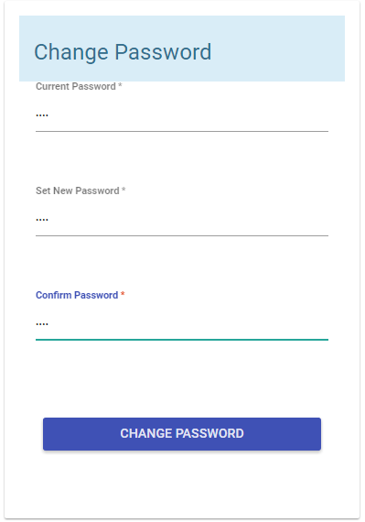

1. Change Password – All fields are required to change the password, it contains the following fields: Current Password, New Password and Confirm Password. To enable the change password button, the user must input the correct current password. The new password and the confirm password should match.

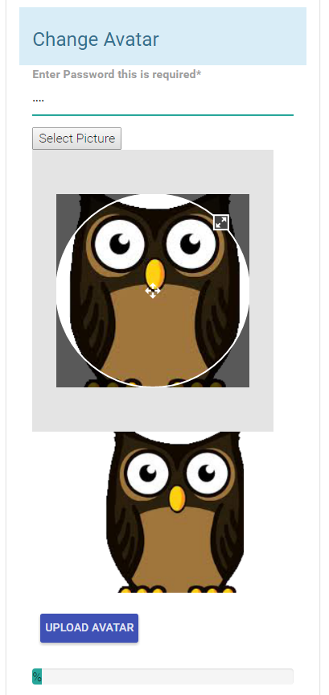

1. Change Avatar – The user must input the correct current password to enable the upload avatar button. By clicking the select picture button, the user can browse and select a picture. The image preview will show in an image container where the user can crop the image. When done, click the upload avatar. The info message will pop-up showing the status of the upload image.

*Note: The avatar image will take effect after the user will log-in in the PMIS.*

**PMIS NEW FEATURES**

In this new version of PMIS, the developer added new features that improve work efficiency of the User and better response and interaction with the forms and tables. The following is the new features of the PMIS.

**Table Pagination**

All tables in the PMIS used pagination to reduce the latency and content delivery of the data, while custom paging improves the performance of default paging by retrieving only those records from the database that must be displayed for the particular page of data requested by the user.

By default, the table will display 10 rows of records. The maximum number of records to display per page is 30. The user can navigate the page by clicking next page button and previous page button. There is also a page selector, if the user wants to jump to the selected page number. Another feature added in the table is freezing the first column, keeping them in view while the user can scroll horizontally. See the screenshot sample below.

**Monitoring & Evaluation Account**

The Monitoring and Evaluation Account page is a comprehensive data visualization that displays the current status of metrics and key performance indicators of all the banners/programs using digital dashboard where the data are presented through interactive charts and tables. With this implementation, it helps to track the progress of the banners/programs against set plans, identify the trends and patterns, adapt strategies and inform decisions for project/program management. The user of the monitoring and evaluation account has the access of all the data records of banners/programs where they can view the progress status of physical, financial and beneficiary accomplishment in a real-time event. They must check and review the quality of data of each banners/programs to ensure the validity and reliability of data reports generated through the PMIS. Although, they cannot modify the data but they have to inform the banners/programs to re-evaluate the data reflected in the system.

* + 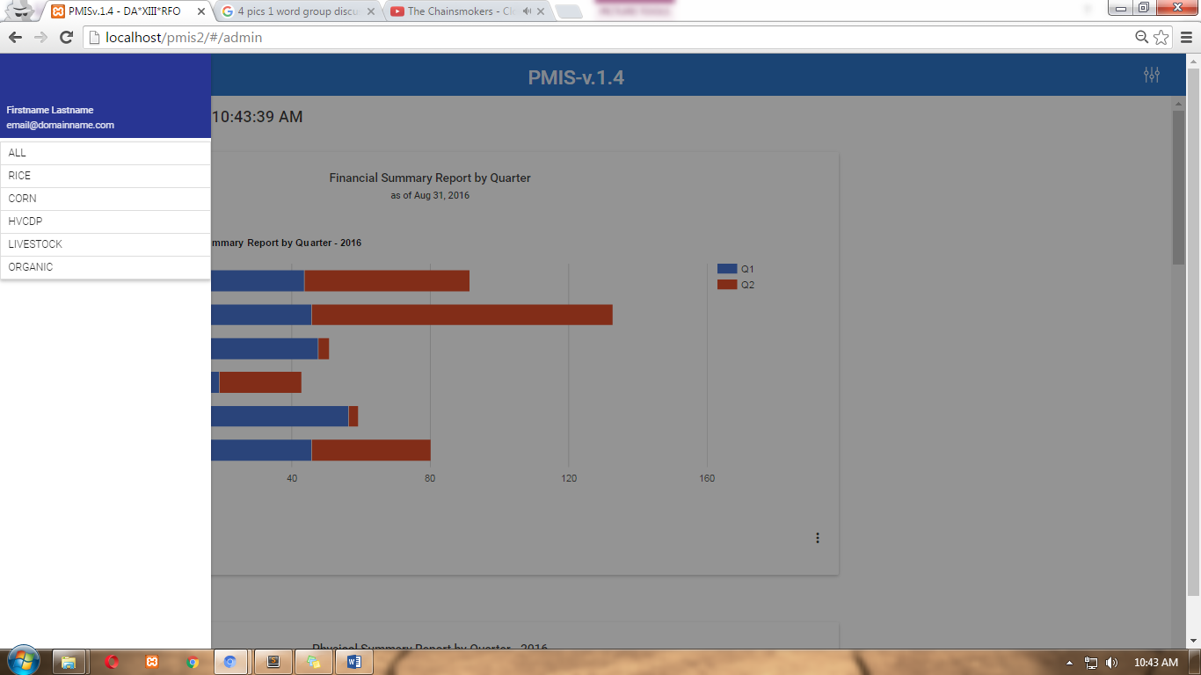**Menu –** this shows the different interface the Monitoring and evaluation officer can view. “ALL” is for the over-all reports of different programs/ banners. “RICE” is for the physical and financial report of the rice program, “CORN” is for corn program, “HVCDP” for high value crops, “LIVESTOCK” for livestock program and “ORGANIC” for organic agriculture program.
    1. 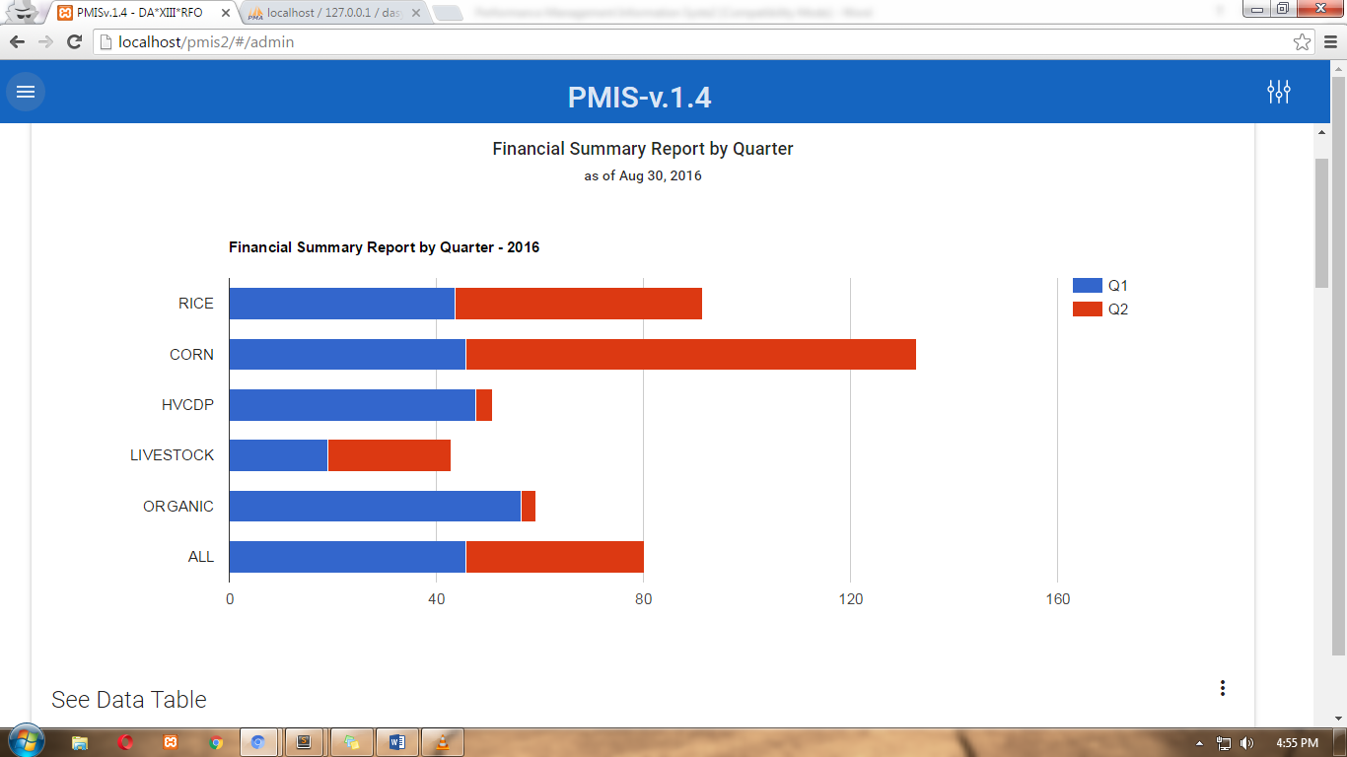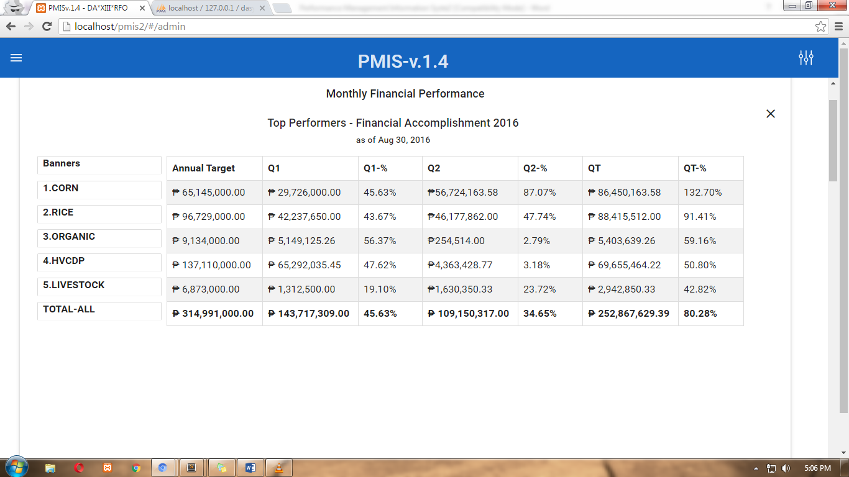**Financial Summary Report by Quarter (By Program)** – this shows the comparison between each program’s financial accomplishments by quarter. Its table also shows program's financial accomplishment versus its annual target.
    2. **Physical Summary Report by Quarter (By Program) –** this shows the comparison between each program’s physical accomplishments by quarter. Its table also shows the physical accomplishment percentage by quarter.

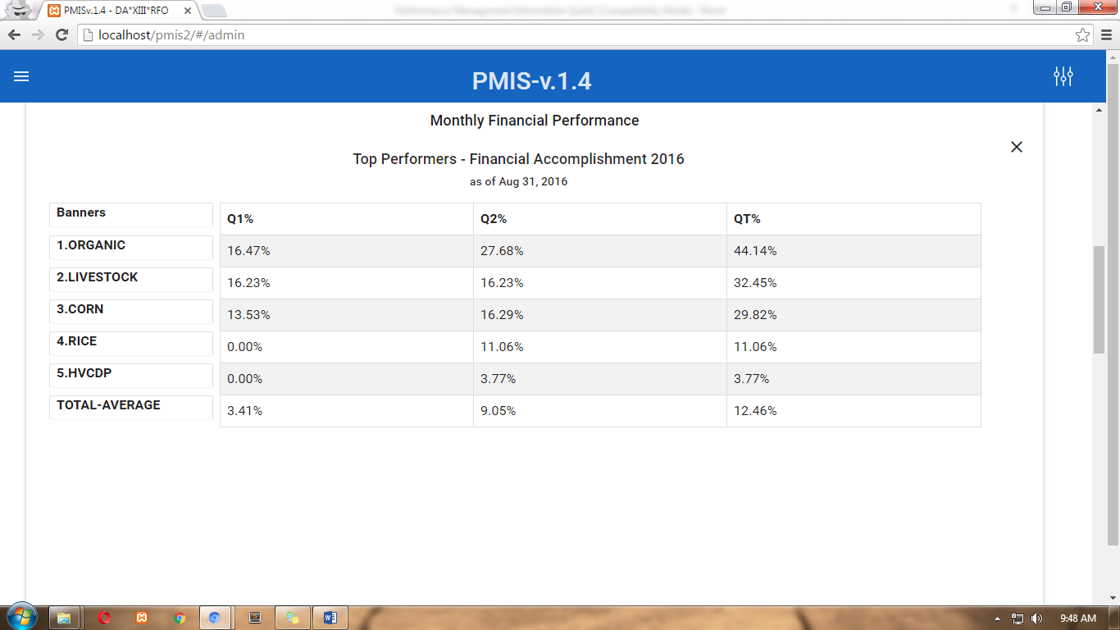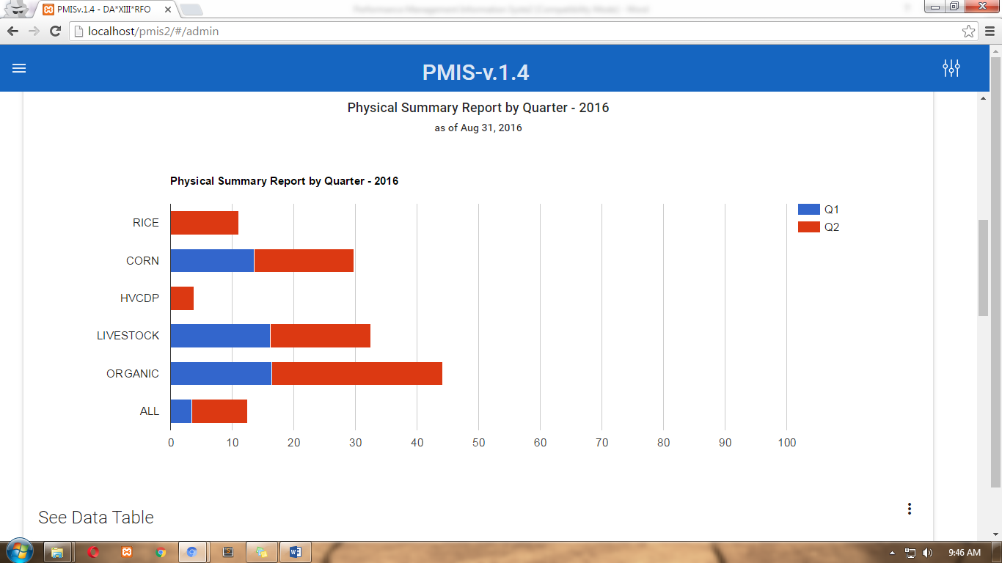

* + 1. 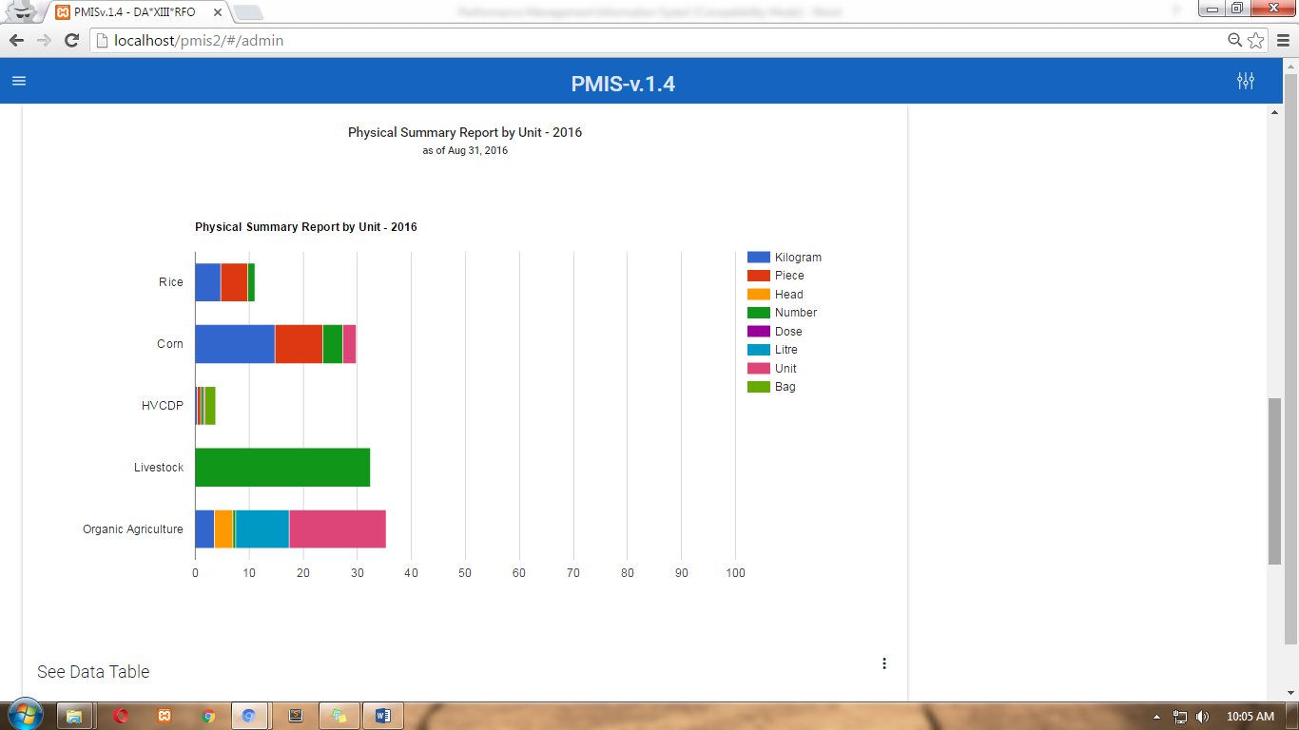**Physical Summary Report by Unit (By Program) –** this shows the comparison between each program’s physical accomplishments by unit. Its table also shows the physical accomplishment percentage by unit of measure versus its annual target.

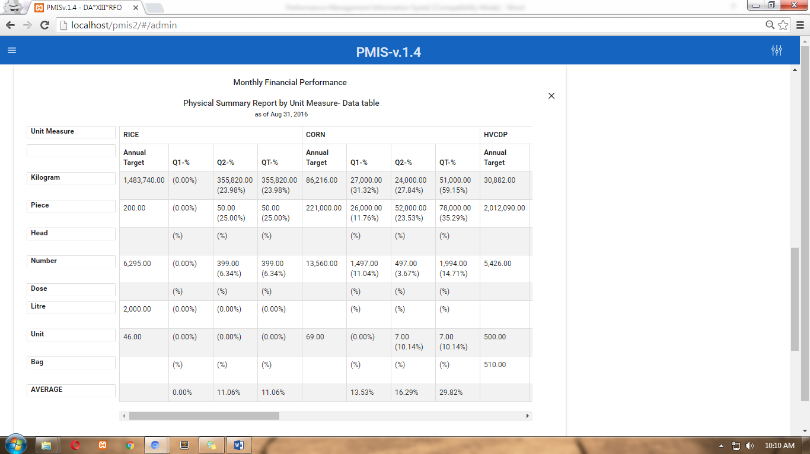

* + 1. 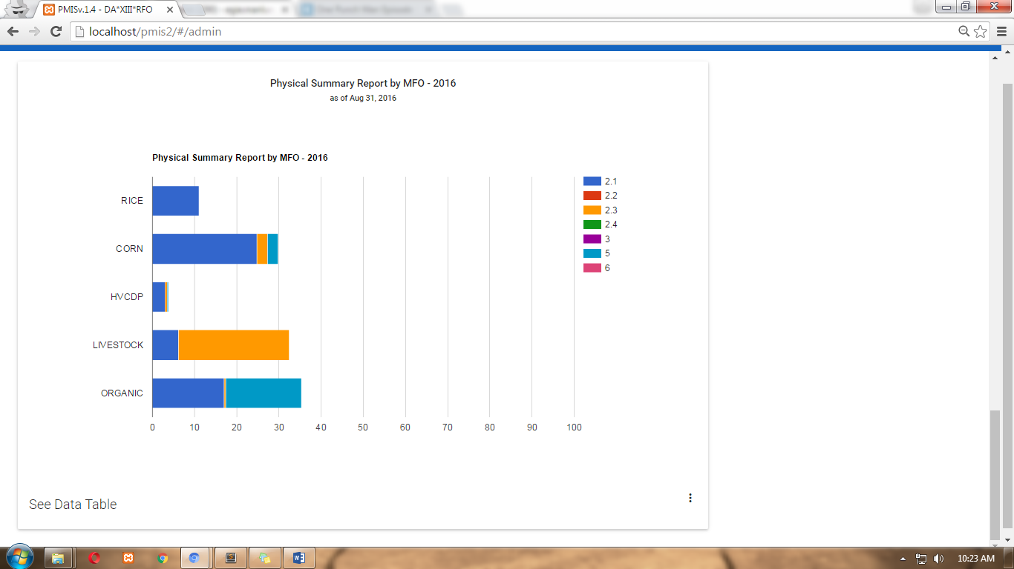**Physical Summary Report by MFO (By Program) –** this shows the comparison between each program’s physical accomplishments by MFO. Its table also shows the program’s physical accomplishment percentage by MFO and by quarter.

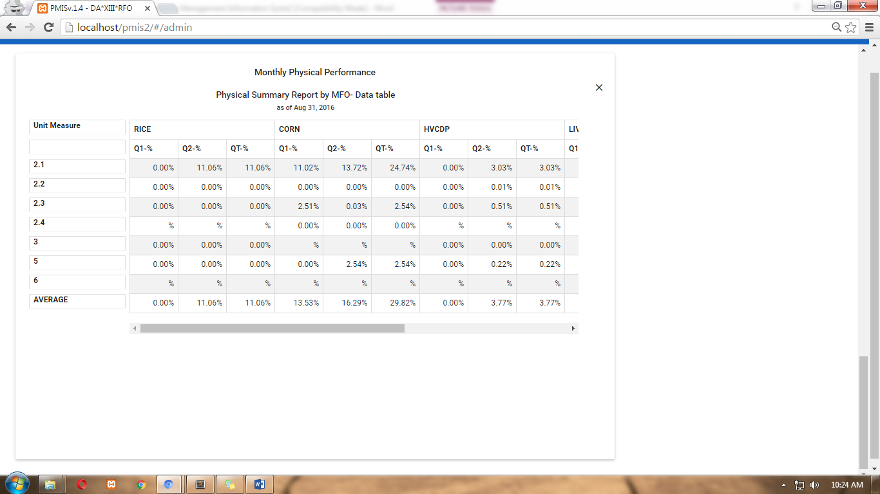

**Downloads – Export Data to Excel**

Another features added in the PMIS is the Download Page where all the list of downloadable data can be exported to excel format. The Download Page can be found by clicking the more settings button in the title bar menu. See sample screenshot below.

